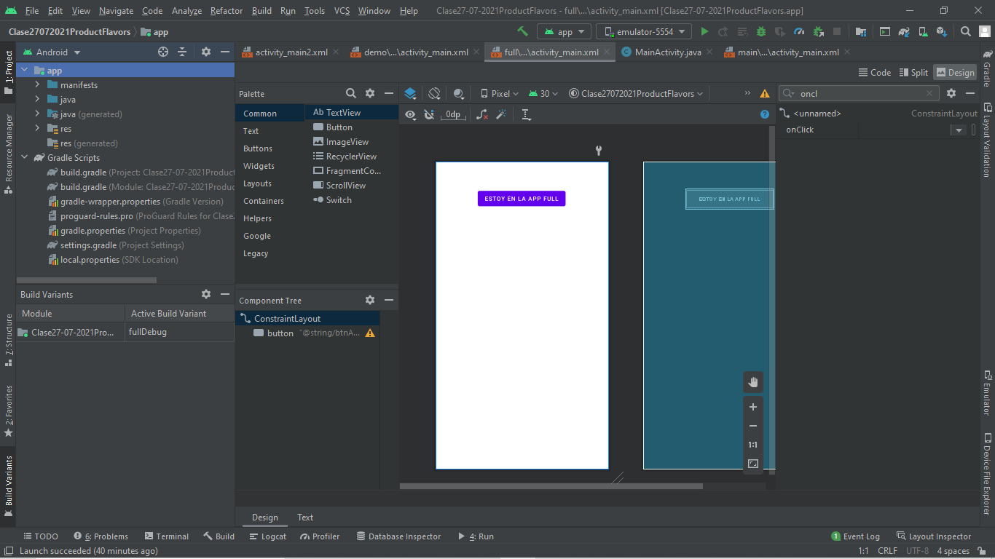
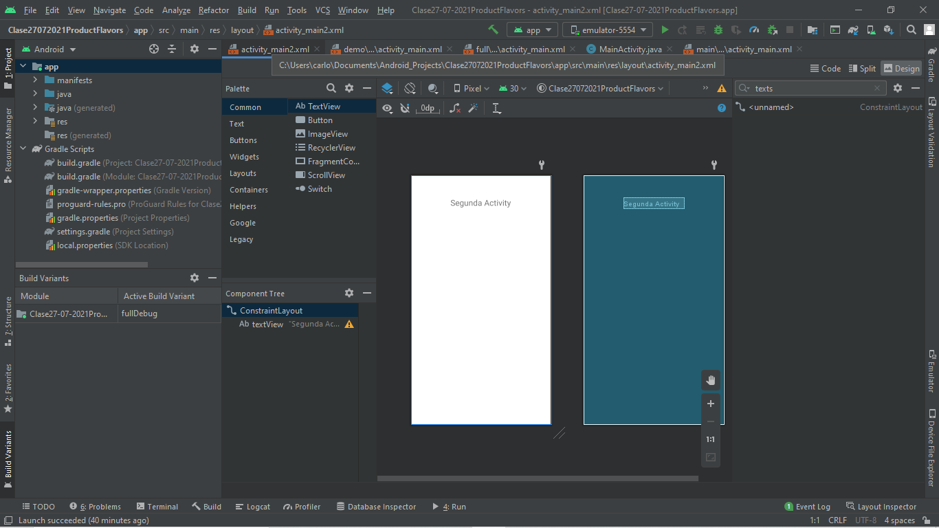

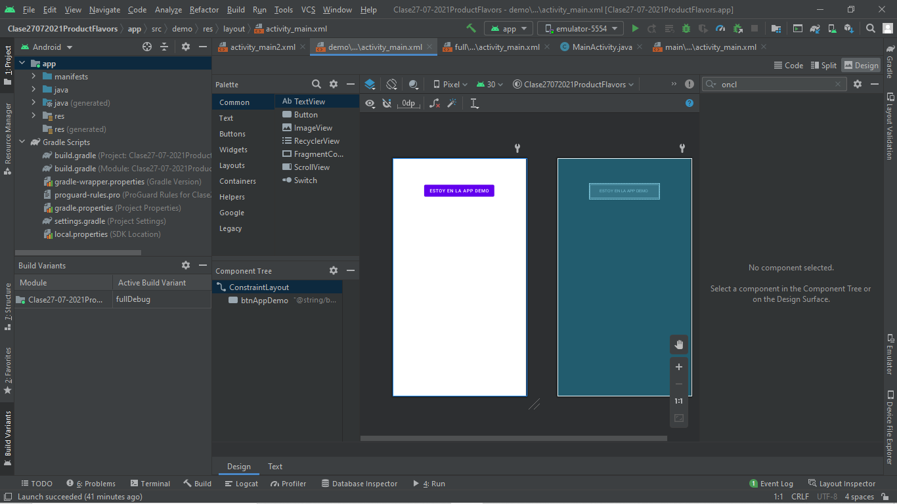

//CODIGO
package com.lost.clase27_07_2021productflavors;
import androidx.appcompat.app.AppCompatActivity;
import android.content.Intent;
import android.os.Bundle;
import android.view.View;
import android.widget.Toast;
public class MainActivity extends AppCompatActivity {
@Override
protected void onCreate(Bundle savedInstanceState) {
super.onCreate(savedInstanceState);
setContentView(R.layout.activity_main);
}
public void cambiarApp(View view){
Intent intent = new Intent(this, MainActivity2.class);
startActivity(intent);
}
public void advertenciaPago(View view){
Toast.makeText(this, "Debe comprar la version de pago",Toast.LENGTH_LONG).show();
}
}

